Student worksheet

2.8 Weathering and erosion can be prevented

Pages 32–33 and 166

Weathering and erosion

1 What is the role of a soil erosion engineer?

2 Why is there a need for this type of engineering?

3 What has happened to the population of Australia in the last 100 years?

4 What result has this had on Australia’s waterways?

5 Why is the removal of plants from waterways causing soil erosion?

6 What impact is soil erosion having on roads and building that are located near waterways?

7 Explain why the event in the following picture occurred.

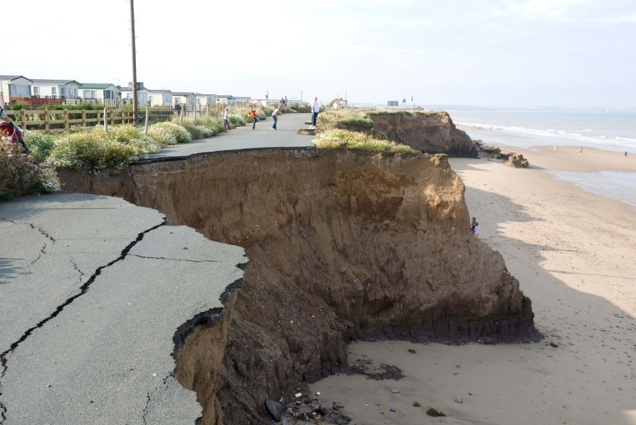

8 Match each of the following engineering solutions to the corresponding explanation of how it works to solve an erosion problem.

|  |  |  |
| --- | --- | --- |
| engineering solution |  | Explanation |
| 1 Control flow of water |  | A Avoids temperature erosion that results in cracks |
| 2 Terraces |  | B Prevents moss build up that results in biological or chemical erosion |
| 3 Grooves in cement |  | C Minimises the erosion of farms and river banks |
| 4 Holes in bricks |  | D Prevents erosion of beaches caused by waves |
| 5 Groynes |  | E Allows water to follow a set path that is protected from erosion by mad-made structures to minimise damage (e.g. drains) |
| 6 Regular cleaning |  | F Allows water to move into the soil rather than contributing to run-off |

Extend your understanding

9 Discuss the ways in which humans are responsible for

a weathering

b erosion

10 Outline two possible solutions for

a man-made weathering

b man-made erosion